**Re-signing and installing SafariLauncher on iOS**

In real iOS device you can’t install Safari app, so using SafariLauncher launch via appium to launch and navigate to Safari browser.

To install **SafariLauncher** in your device, you must have an Apple iOS developer account.

**Resigning SafariLauncher**

The following procedures for re-signing the **SafariLauncher** app can only be performed from an OS X machine:

1. **Optional:** If the test machine does not yet have a development private key already imported into the Keychain Access application, go ahead and import the private key file (*.p12) on your test machine:
   1. If you need to export the development private key from another test machine, select Applications > Utilities > Keychain Access. In the Keychain Access window, click login in the Keychains panel, then click Keys in the Category panel. In the Name panel, expand the imported private key node you want to use, right-click the certificate, select Export and save the keychain file.
   2. Import a development private key file (*.p12) into the test machine's Keychain Access by double-clicking the private key file. If requested, enter the file's password. The development private key is imported into Keychain Access on the test machine.
2. Obtain the full name of the private key from Keychain Access:
   1. Open Keychain Access from Applications > Utilities > Keychain Access.
   2. In the Keychain Access window, click login in the Keychains panel, and then click Keys in the Category panel.
   3. In the Name panel, expand the imported private key node you want to use, right-click the certificate, and select Get Info on the context menu.

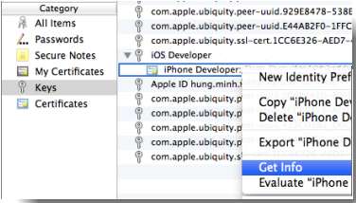

* 1. Make note of the device's provisional Common Name

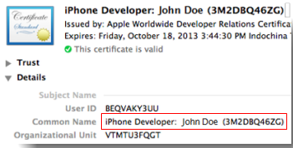

1. Create the provisional profile file(*.mobileprovision) from apple developer page(<developer.apple.com>) with your Bundle, and please keep in mind to run **config Appium**, ex: “**com.logigear.SafariLauncher**” and download in your Mac.

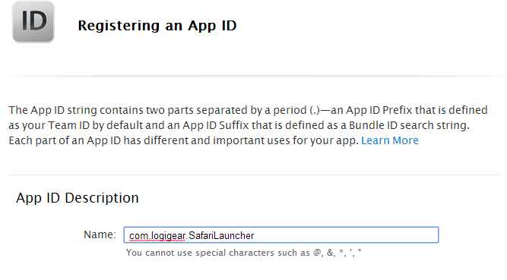

1. File SafariLauncher.ipa, it has in this Project.
2. Using iResign app to resign your provisioning profile in SafariLauncher.ipa, download here <https://github.com/maciekish/iReSign>.

Open iResign.app

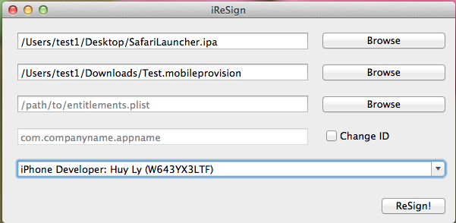

1st field this is path of SafariLauncher.api location.

2nd field this is path of provisioning profile you just created from apple developer page.

3rd field this is path of entitlement.plist (this is optional).

4th field type your bundle id of provisioning profile(ex: **com.logigear.SafariLauncher**), you can ignore this step, this app will auto sign bundle of your provisioning profile.

The last field, this is developers have in Keychain. Choose your developer.

Click ReSign button and save new SafariLauncher.ipa.

**Installing SafariLauncher**

Double click on SafariLauncher.ipa, automatically open iTunes.

Connect the iOS device to the test machine using a USB cable.

Choose SafariLauncher and click Sync button, SafariLaucher will be installed in your device.

**Notice**:

To open SafariLauncher via appium, when you config and run appium in terminal **appium –a <address> -p <port> --app com.logigear.SafariLauncher –U <udid>,** the Bundle ID has to the same Bundle ID in your provisioning profile you created in apple developer page.